Task Details
-Aditya Bikram Arandhara
Aim: To develop a web-page for blogs for a dog adoption NGO which contains a backend section to add and delete blogs.

Tools used: HTML, CSS, PHP & MySQL

Screenshots:
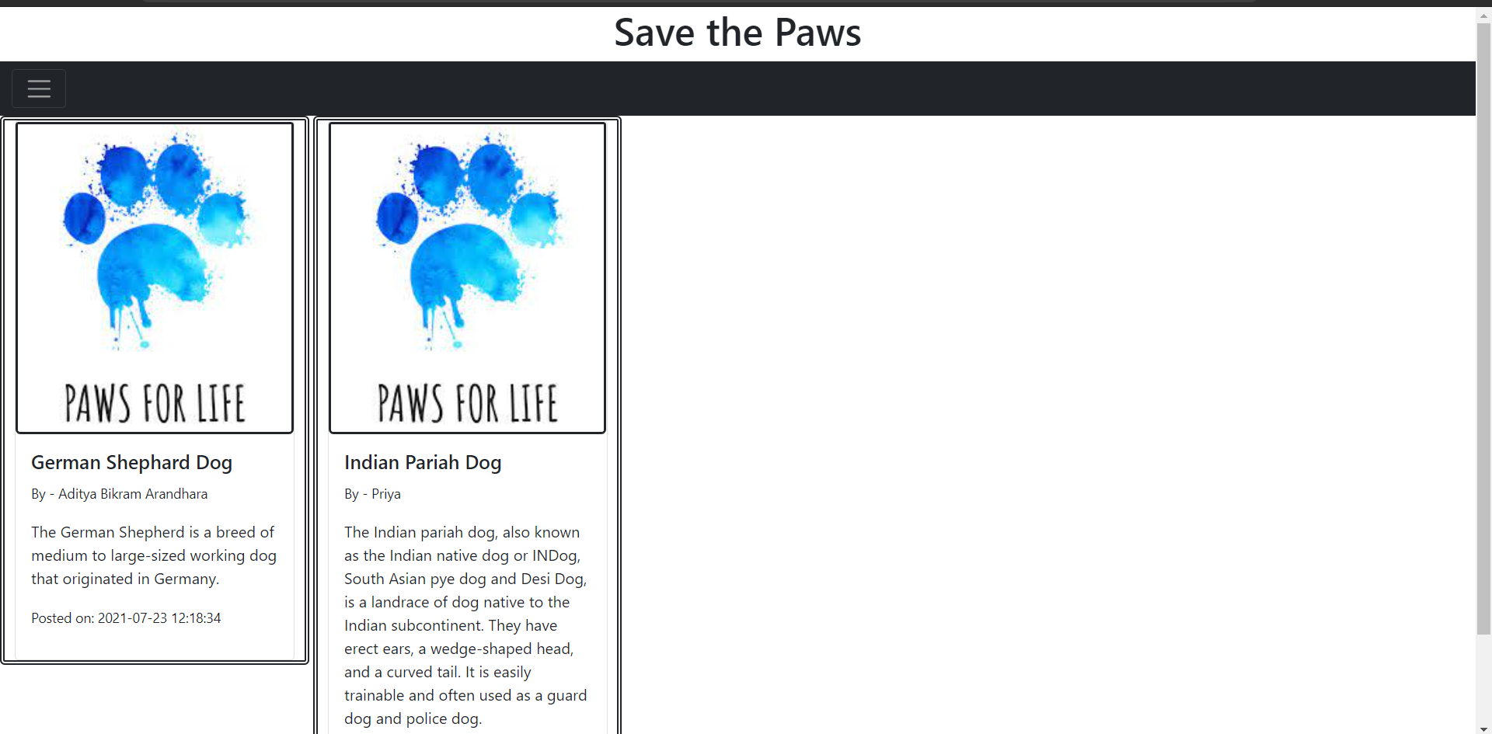
Fig: User view

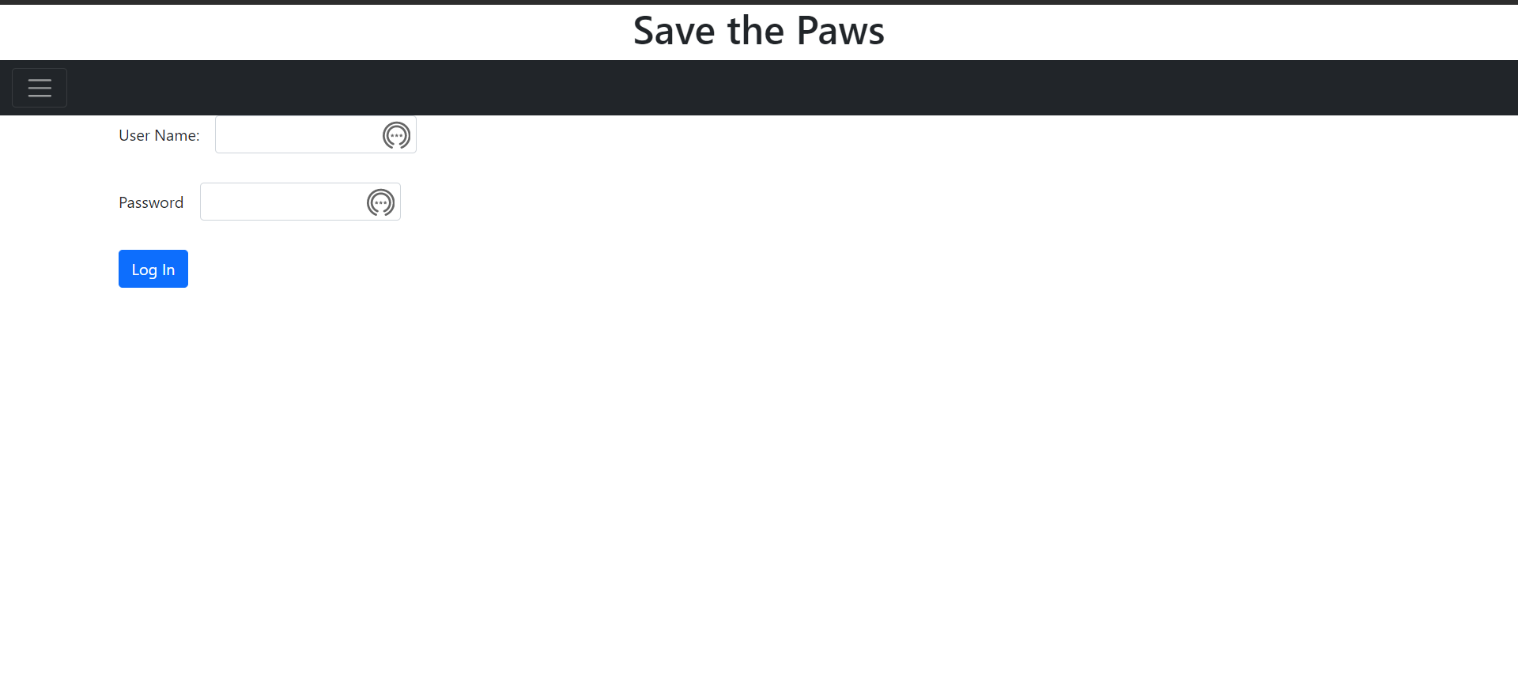
Fig: Admin Login Page

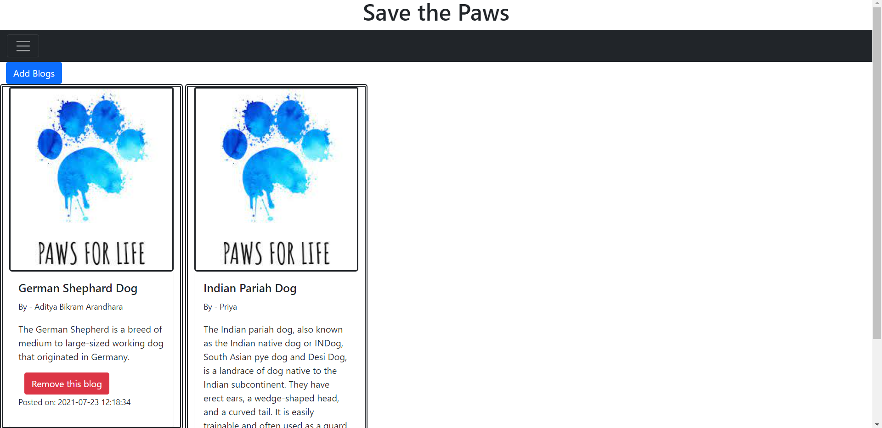
Fig: Admin View

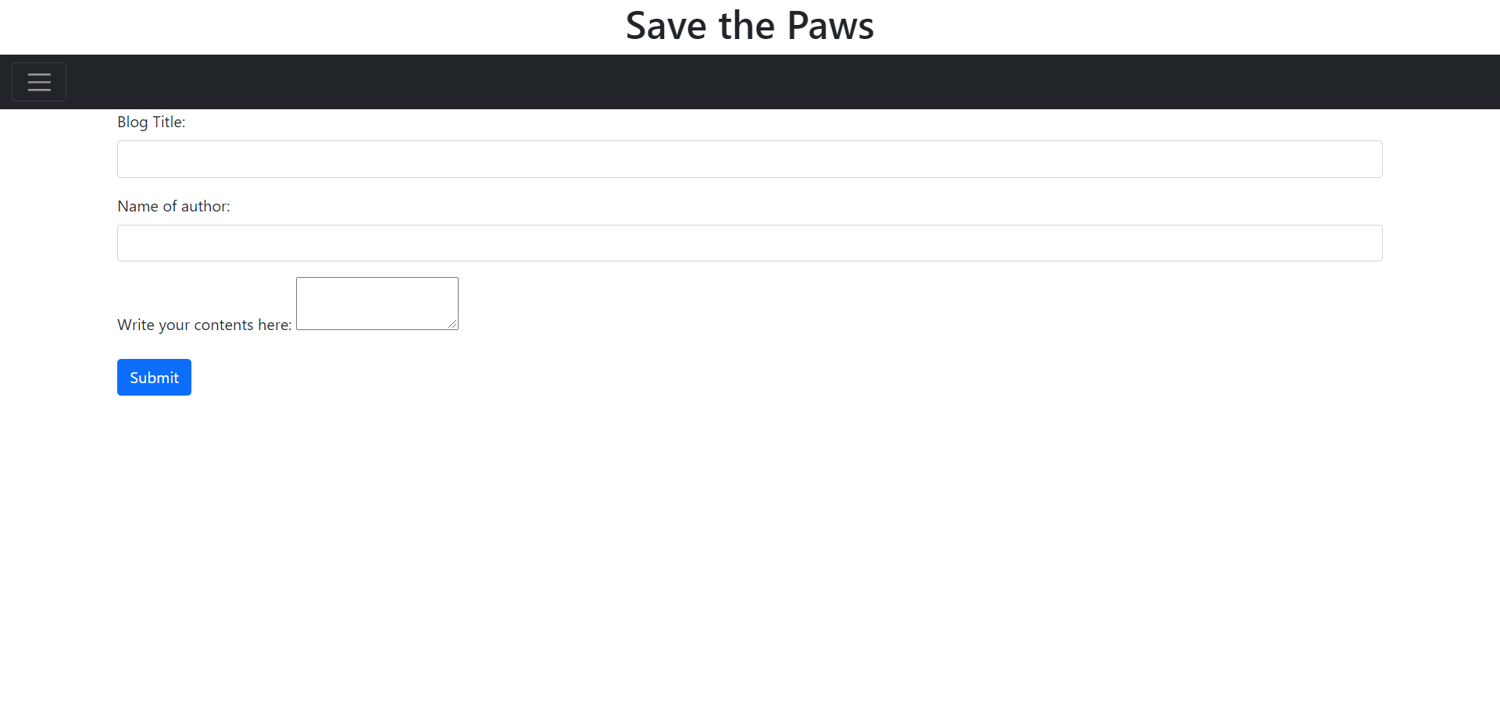
Fig: Add Blogs page

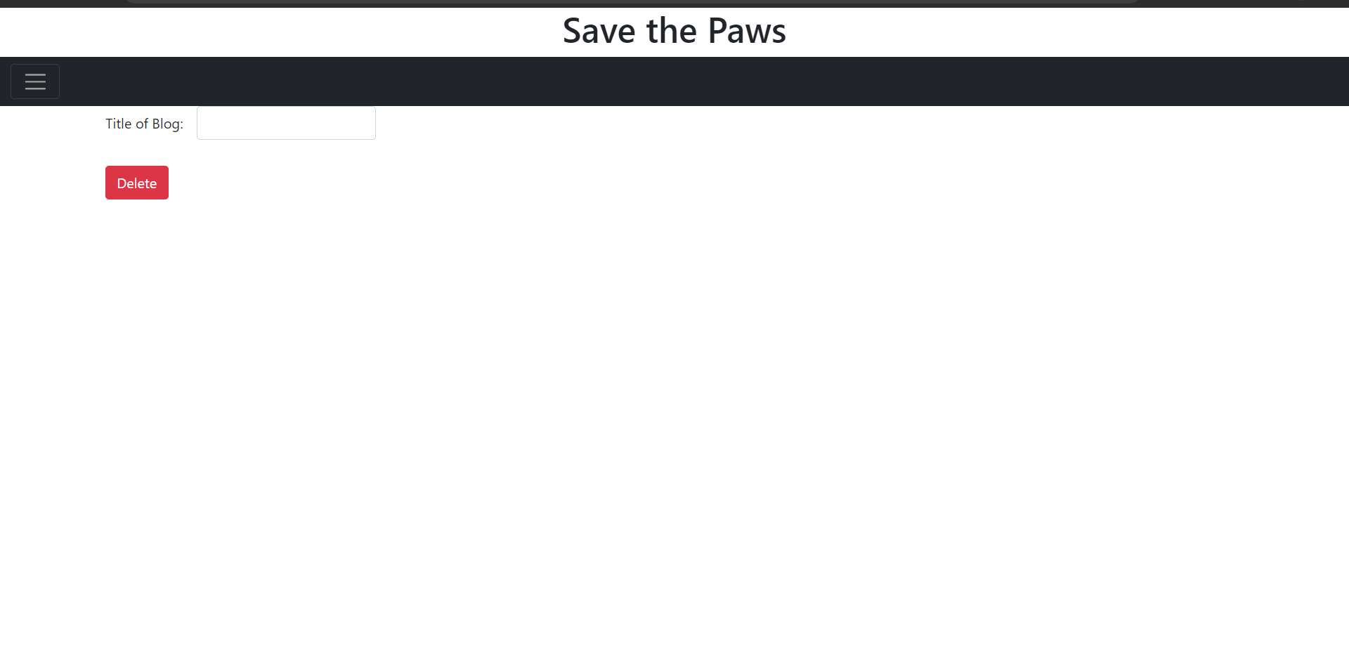
Fig: Remove blog page

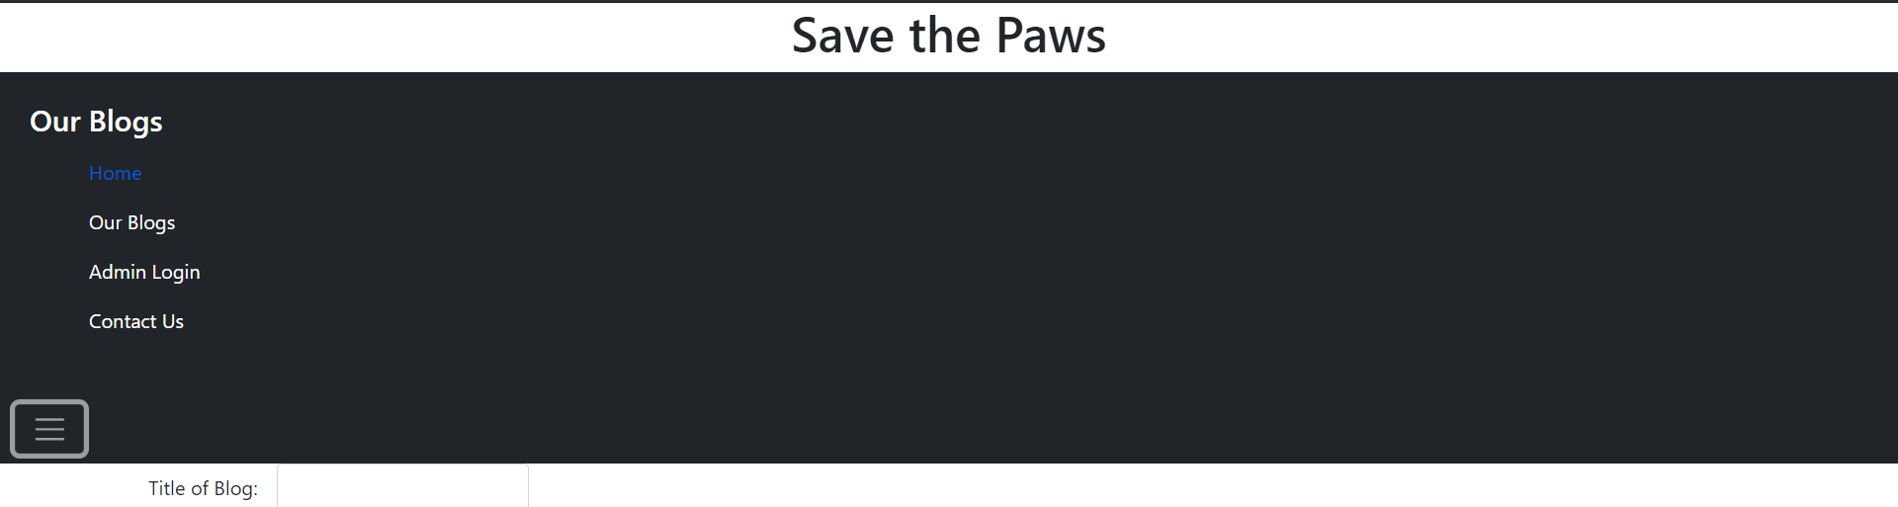
Fig: Navigation bar

